Request For Proposals : Building Our Climate Workforce - Learning from Potential Climate Workers
Contact Information
Cara Robechek, crobechek@eanvt.org, 802-552-8450
Timeline
- Request for Proposals released November 16, 2022.
- Responses due by December 6, 2022 (extended from original deadline of Dec 2)
- Participating organizations will be selected and informed by December 9.
- All participating organizations will be asked to have at least one representative attend a planning meeting between December 12-22 to collaboratively decide on process and questions for collecting information.
- Information collection between January 2-January 31 2023.
- Report on findings due back to EAN by February 15, 2023.
Project background
The goal of this work is to learn from potential climate workforce employees, including individuals who have not traditionally participated in climate occupations, about their employment needs and desires, and the best messaging and approaches to communicate with their demographic. This information will be used to help employers better hire, support, and retain people from these communities, and will inform a communications campaign to help potential workers know more about climate careers.
We are seeking 6-9 organizations whose constituents or communities might be interested in working in the climate workforce, but who are currently underrepresented in these jobs. These might include: refugees, new Americans, people in recovery, BIPOC Vermonters, LGBTQ+ Vermonters, workers seeking retraining from more polluting jobs, formerly incarcerated individuals, youth, etc.
Each of the selected organizations will be asked to conduct a focus group, or similar conversations, with about 10 of their participants to learn about what might make them choose a career in the climate workforce, and how best to communicate with them and their peers about opportunities. The Network Action Team will assist in developing prompts and questions for focus group participants, in collaboration with the selected organizations, on topics such as:
- What is most important for these individuals as they are looking for a job?
- What are their needs including: pay/benefits, flexibility, training, English language support, wrap-around services (child care assistance, transportation, housing etc.), and on the job training and support?
- Is there interest in different work options like a Civilian Conservation Corps, cohort hiring, apprenticeships, serve earn and learn, or summer trainings?
- How do these individuals learn about work opportunities and make career decisions? Where do they get their information? What do they need to know more about to choose these jobs?
- What do they worry about in considering one of these jobs?
- How can we make a career in the climate workforce stand out from other fields that are also struggling with not having enough workers?
Deliverables and Payment
EAN has a maximum of $14,000 available for this work. We are seeking up to 9 organizations that work with a variety of different communities, each of which will receive $1,000 for:
- Attendance at one planning meeting,
- Conducting a focus group or similar conversations with approximately 10 of their participants using the agreed upon questions and structure including a demographic survey,
- Reporting their findings back to EAN in a brief written report.
In addition each organization will receive $500 to pay their participants for their time as a focus group member.
EAN will send a check for $1,000 to each organization as soon as they are selected. The final $500 will be sent when the report is received.

Qualifications
The EAN team seeks organizations with:
- Demonstrated expertise with the priority populations in Vermont listed above.
- Ability to conduct the focus conversations and deliver a brief report back to EAN in the timeline listed above.

Interested organizations should fill in and submit the application below.

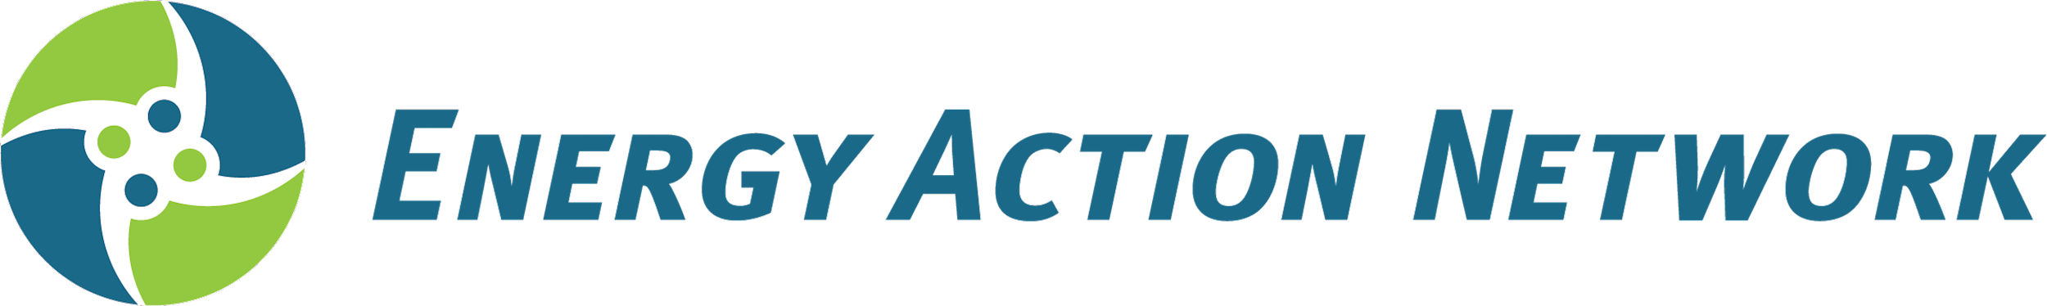
EAN Clean Transportation Equity Application

Please return this form by December 2, 2022 to Cara Robechek (cara@eanvt.org). If you prefer, it can also be mailed to EAN, 17 State Street, Suite 205, Montpelier, VT 05602

Organization Name
Mailing Address
Your Name
Your E-mail address
Your phone Number

If selected does your organization agree to:
- Have at least one representative attend the planning meeting
- Gather information from about 10 participants in January 2023.
- Report your findings back to EAN by February 15 in a written format.

Why should your organization be part of this research project?

If selected, how would you go about having a focus group conversation with your participants?

Describe the kinds of participants you would expect to be able to reach (such as age, gender, race, urban/rural, primary language, etc.)

